public class Grade{

// Returns a letter grade based on the average
static char gradeFunction(double avg) {
if (avg >= 90) return 'A';
else if (avg >= 80) return 'B';
else if (avg >= 70) return 'C';
else if (avg >= 60) return 'D';
else return 'F';
}

public static void main(String[] args) {
Scanner scanner = new Scanner(System.in);

System.out.print("How many grades (1 to 5)? ");
int count = scanner.nextInt();

// Validate the input count
if (count < 1 || count > 5) {
System.out.println("Invalid number. You must enter between 1 and 5 grades.");
scanner.close();
return; // Exit
}

double sum = 0.0;

// Read each grade
for (int i = 1; i <= count; i++) {
System.out.print("Enter grade " + i + ": ");
double grade = scanner.nextDouble();
sum += grade;
}

double avg = sum / count;

System.out.println("Average: " + avg);
System.out.println("Letter grade: " + gradeFunction(avg));

scanner.close();
}
}

FROM eclipse-temurin:17-jdk

WORKDIR /app

COPY . /app

RUN javac Grade.java

CMD ["java", "Grade"]

Basic Image Creation
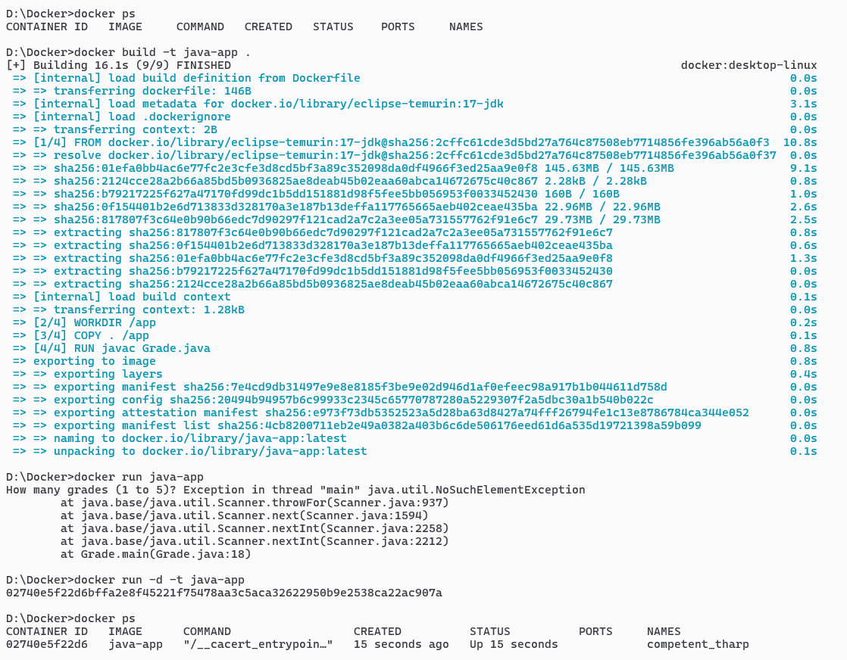
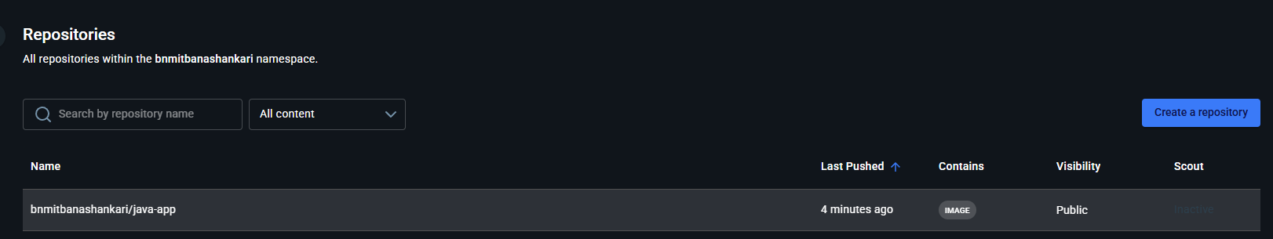
Repository Creation:

Docker Hub Login:
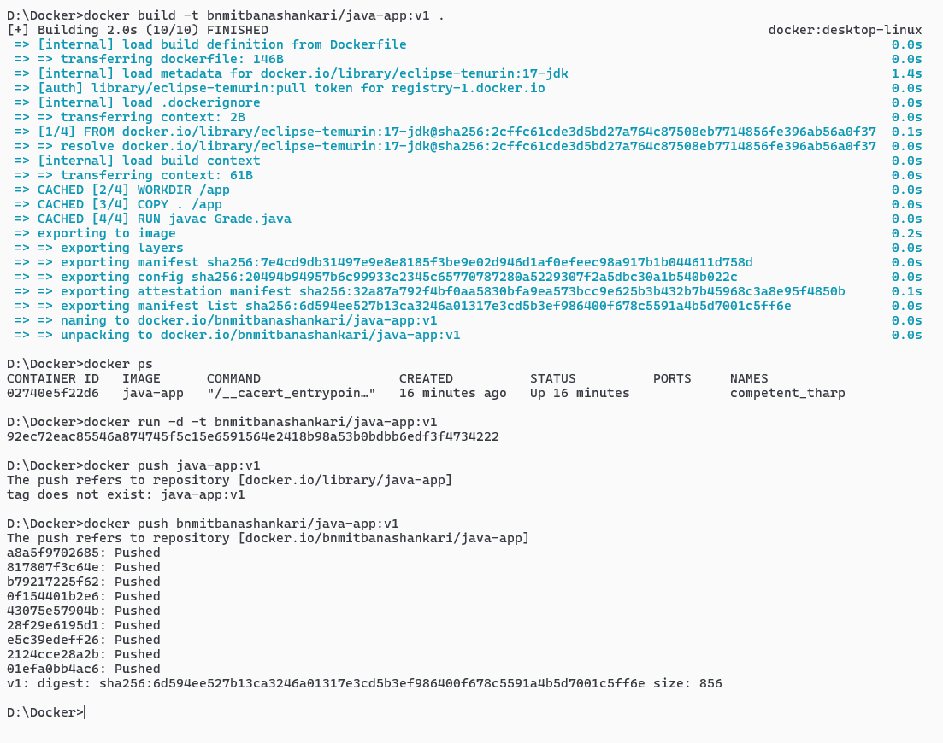
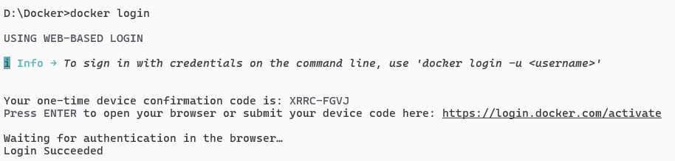

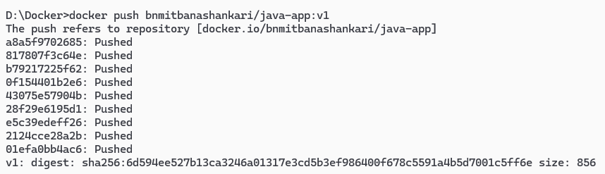

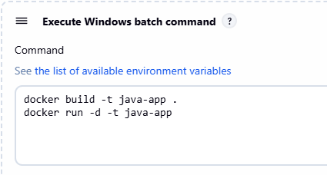
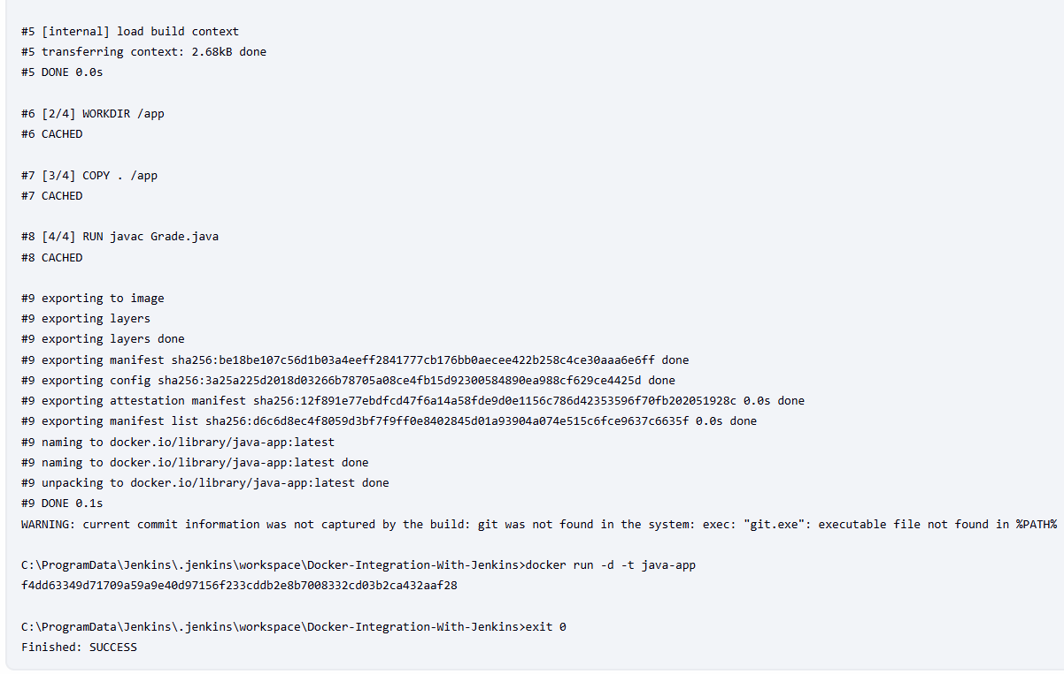
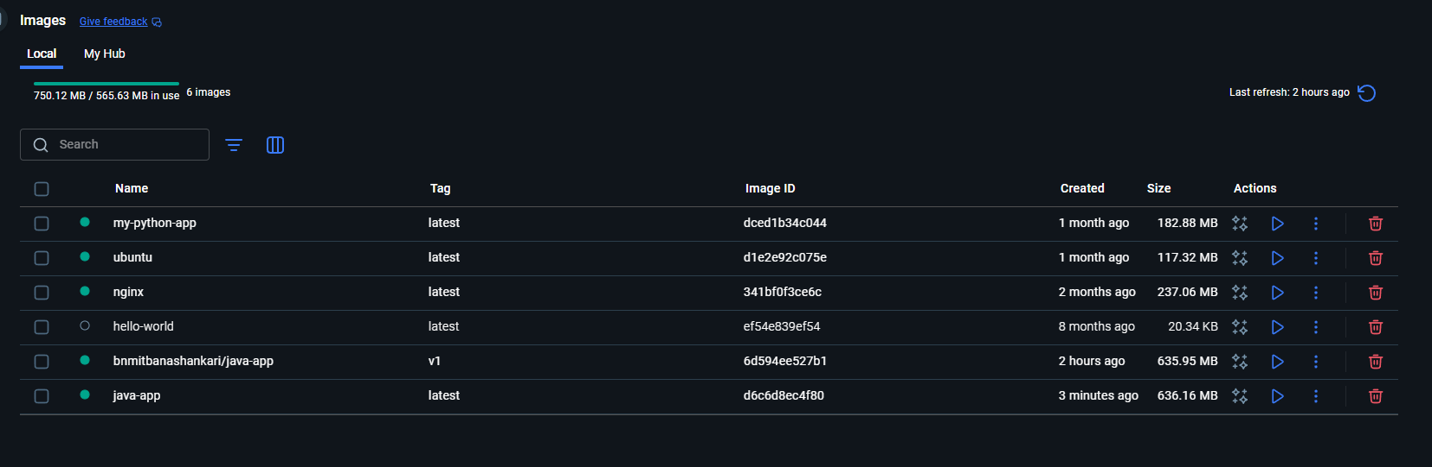
Exp 19:

